**more command:**

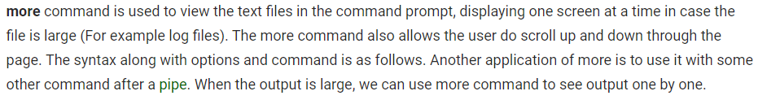

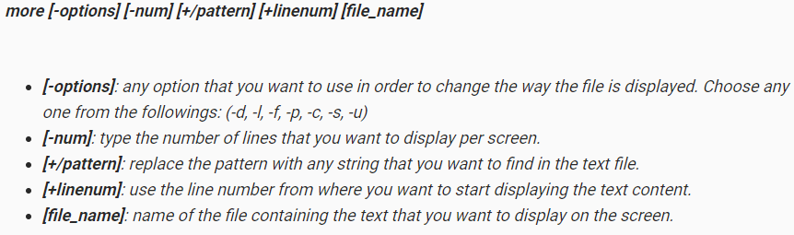

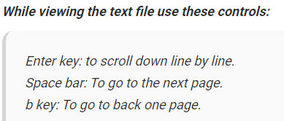

To view the file page after page

* **more filename**

**-d :** Use this command in order to help the user to navigate. It displays “[Press space to continue, ‘q’ to quit.]” and displays “[Press ‘h’ for instructions.]” when wrong key is pressed.

* **more -d filename**

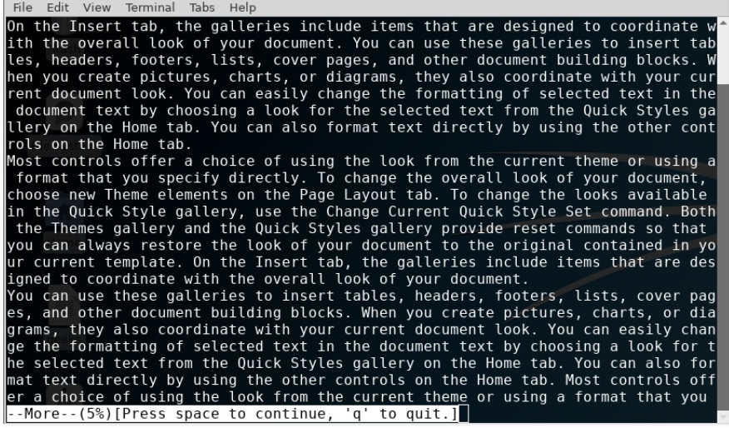

**-f :** This option does not wrap the long lines and displays them as such

* **more -f sample.txt**

**-p :** This option clears the screen and then displays the text.

* **more -p sample.txt**

**-c :** This command is used to display the pages on the same area by overlapping the previously displayed text

* **more -c sample.txt**

**-s :** This option squeezes multiple blank lines into one single blank line.

* **more -s sample.txt**

**-u :** This option omits the underlines.

* **more -u sample.txt**

**+/pattern :** This option is used to search the string inside your text document. You can view all the instances by navigating through the result.

* **more +/reset sample.txt**

**+num :** This option displays the text after the specified number of lines of the document.

* **more +30 sample.txt**